Please complete and return
by fax to + 32 2 647 59 34
or by email to i.fusco@erf.be
by 3 November 2011
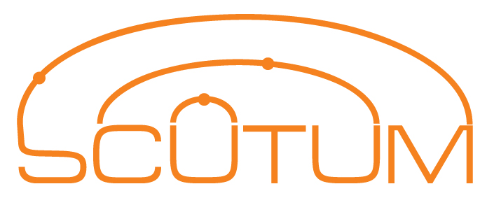
WORKSHOP

EGNOS breakthrough in the road
9 November 2011, Roma Eventi - Fontana di Trevi
Piazza della Pilotta, 4 – Rome (Italy)

Reply Form
Please select among the following

□ | I will attend the SCUTUM Workshop (free of charge)
□ | I will attend the EasyWay Annual Forum*
Name

Organisation

Email

*Please note that in order participate to the EasyWay Annual Forum, you need to register through the dedicated website http://www.easyway-its.eu/1/

