ITS Network Meeting, 4-5 October 2010, Timisoara, Romania

The Network of National ITS Associations recently spent two very interesting days in Timisoara hosted by ITS Romania. The first day was held at the Recas Winery just outside Timisoara where the new eSafety Observers Network, including many ITS Nationals held their kick-off meeting.

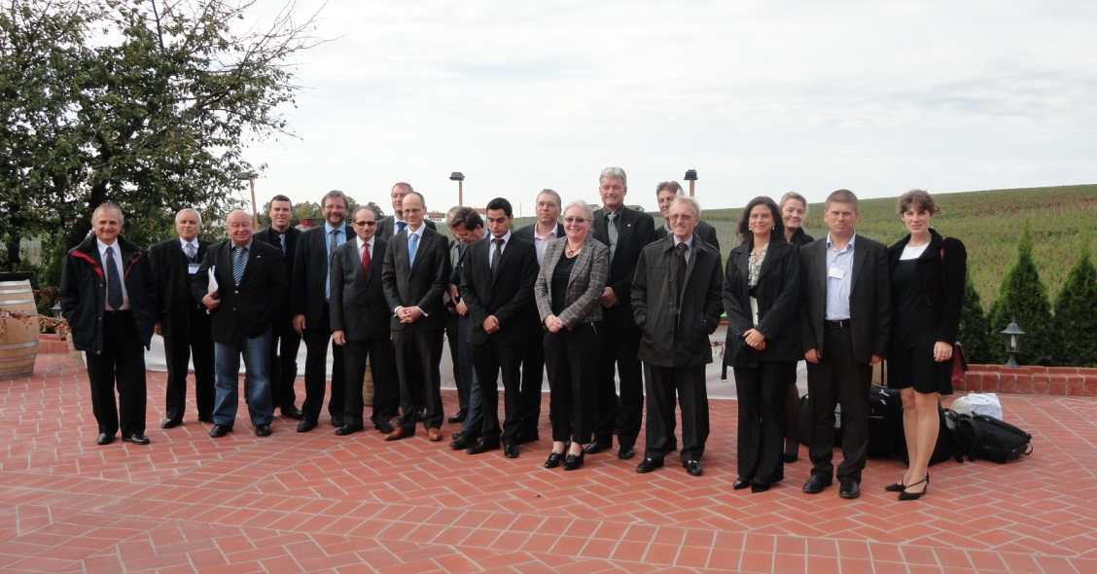

During the afternoon, the Network Plenary meeting took place where thirteen ITS National Association members were present in addition to ITS Bulgaria who attended as an observer. Members were able to exchange information current activities within their countries as well as to discuss the objectives of the Network. In addition, members were given an update as to opportunities for closer collaboration with ERTICO including the i-Mobility Network, cooperation regarding Congresses and a survey on existing and deployed ITS services within their countries. The meeting was followed by a Networking dinner which included wine tasting and allowed members to appreciate fully Romanian hospitality.

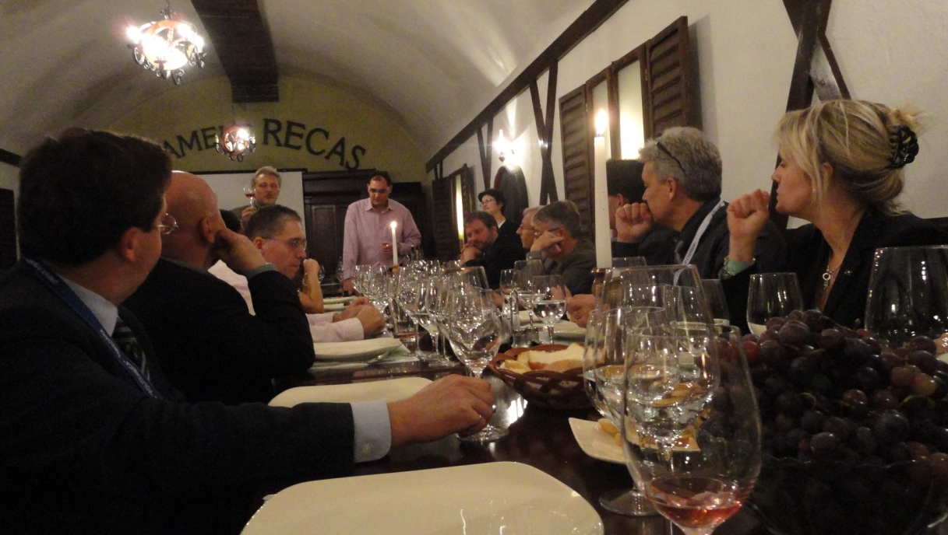

The second day comprised a Workshop held at the Politehnica University of Timisoara where Network members were able to learn more about the ITS Status and Vision of the Romanian National Road Network, Vision 2030 and the work of the ITS Institute within the Politehnica University of Timisoara. In addition, presentations were given on the iCar Initiative, Education in ITS from the Swedish perspective and the eCall Pilot Project – HeERO. The workshop was followed by a very informative visit to the Public Transport Management Centre in Timisoara, where the management of buses and trams was explained in detail.
***
More information about this press release is available from: Jennie Martin tel: 00 44 20 7709 3003 or mailbox@its-uk.org.uk More information about the Network is available from: Anna Limbrey tel: 00 32 2 400 07 19 or a.limbrey@mail.ertico.com
Visit www.itsnetwork.org

ENDS

