 | 
Cooperative Cities extend and validate mobility services | http://www.co-cities.eu

Press Release

September 2011
Co-Cities: COOPERATIVE MOBILITY SERVICES TO IMPROVE URBAN TRAFFIC MANAGEMENT
Pilot project Co-Cities incorporates travellers’ feedback to existing mobility services to offer better transport information services
The EU co-funded pilot project Co-Cities (Cooperative Cities) aspires to extend and validate existing mobility services to improve current traffic information management in cities and urban areas. The novelty about the Co-Cities services is their cooperative feature permitting the end users to report their feedback to the traffic management. The project will run for 3 years and pilots will be tested in the cities of Bilbao, Munich, Prague, Reading, Vienna and in the Tuscany Region site (this site will include information services available in different Tuscany cities and over the regional area).
Feedback Loop
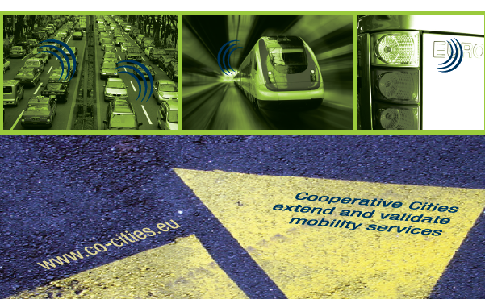
Up to now, transport information services included dynamic navigation, intermodal routing and real time advice, but did not deliver information sent out by the traveller to traffic management. Co-Cities will take up the idea of mutual information exchange and develop a dynamic feedback loop from mobile users and travellers to the cities' traffic management centres adding cooperative mobility to traffic information services. Using this feedback loop the project extends and validates integrated multimodal information services and enhances the quality for all users. Data communication will be based on the In-Time Commonly Agreed Interface (CAI). This interface is a R&D result of the European project In-Time (Intelligent and Efficient Travel Management for European Cities) and provides common interface between city traffic management information and the Transport Information Service Providers (TISP).

Objectives
Co-Cities aims to achieve a number of objectives envisioning to improve the traffic information distribution and to adapt it to the users’ needs:
- Extend the In-Time Commonly Agreed Interface with a feedback loop to enrich mobility services with cooperative elements.
- Extend the number of cities which install this interface and connect it to the traffic management centre for a regular feed of data and information.
- Develop a fast and reliable validation process for cooperative traffic information services.
- Contribute to the objectives of improved road safety, increased energy efficiency, higher comfort and sustainability of transport in urban areas.
- Make transport information services more attractive and appealing to users in urban areas.
Co-Cities services
Co-Cities delivers common traffic information services in European cities by generating and collecting the necessary data directly from the involved transport operators in the area and exchanging this information between different actors via the In-Time interface. Further, Co-Cities enables the customisation to the needs of single user groups by the respective service provider and maintainer. The core information services of cooperative cities are:
- Road traffic and event information
- Parking information in urban areas
- Public transport information
- PT journey planning and route guidance
- Walking and cycling information.
The real challenge for cooperative cities and service providers is the accuracy and quality of the services. These services will be presented in an integrated and consumer friendly way giving the end user the option to directly feedback traffic related events to the cities’ traffic management centres. With this feedback loop from the users to the traffic management Co-Cities can react to changing traffic conditions and adapt their traffic management and control plans faster than before, communicate changes dynamically to travellers and people on the move and enhance mobility in urban areas.
The result of Co-Cities will on the one hand be interoperable and multimodal RTTI (Real time traffic information) services to end-users using different hardware and software platforms such as personal navigation devices, smart phones and web services and develop Europe–wide services based on regional traffic and travel data. On the other hand Co-Cities will offer Business-to-business services which enable Europe-wide Traffic Information Service Providers (TISPs) to cooperate with regional and urban authorities in fields such as strategy-based routing and adaptive mobility services
European initiative
The transport information services of Co-Cities are developed in a European partnership of 14 partners. The consortium consists of cities, public authorities, transport operators and regions providing high quality traffic information and of Traffic Information Service Providers which bring in their relations to the end users and customers. Co-Cities started in January 2011 and will finish in December 2013.

For further information please contact the Co-Cities coordinator Alexander Frötscher, AustriaTech: alexander.froetscher@austriatech.org (+43 1 26 33 444 64)







