Best practices Form

The objective of this document is to exemplify ITS and C-ITS deployments in different areas within Europe. Please reply to the questions below and follow the model provided. You can submit your Best Practice until the 15th of May 2019, by email to Manuela Flachi, Manager, ERTICO – ITS Europe, at m.flachi@mail.ertico.com. The best submission will win a trip to the ITS European Congress to present the best practice at the ERTICO stand. In addition, you will be given the opportunity to have your Best practice solution published in the Congress newsletter giving you recognition as pioneer (‘Champion’).
Thank you for your submission!

Name of Best Practice
 | Name and organisation submitting the Best Practice:
Initial needs and challenges | What were the challenges and needs to be addressed that led to the implementation of this solution? Can you provide some figures and targets?
Short description of the service(s) provided | Provide a description of the solution. It should contain technical elements, but not go too deep into technical details. Need for external data sources should be mentioned.
Covered area (city, region, corridors)

Business model | If possible the Business Model Radar shall be used – Image below  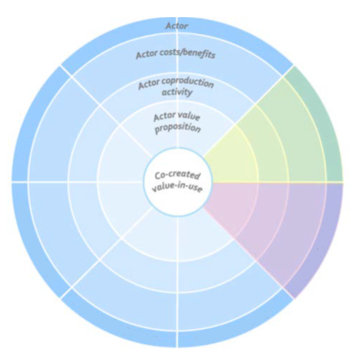  Commuter
Stakeholders involved (customers, focal organisations, supporting partners) | List of stakeholders involved, brief description of their role and level of engagement with other stakeholders
Value in use (positive impact) | Please describe the main benefits brought by the implementation of the solution. Impact assessment and evaluation results should be included if available.

Example: Vienna Mobility as a Service solution
Initial needs and challenges | The Wiener Stadtwerke Group is among the top 25 companies in Austria and makes an important contribution to the daily operation of the City of Vienna. Wiener Linien, Vienna’s public transport operator, is committed to providing the best service possible, and thereby to steadily increase the public transport share of city traffic. The Viennese appreciate this effort: With 38% of all passenger trips in Vienna made using public transport, the lines annually carry a higher share of the city’s passenger traffic than automobiles do. Along with the raising attractiveness for public transport and other ways of travel, there is also an increasing need for a coherent and reliable mobility solution.  Nevertheless, Vienna has a growing population and the groups of 60 years and older, as with 20 years and younger, are increasing. Therefore, the incentives for a convenient solution for all inhabitants increase over time.  The first initiative to transform Vienna into a city of mobility was the Smile project. The goal of the project was to create a mobility platform that not only allowed the user to inform oneself about all available means of transport, but even to let the customer book, pay and use the different means, with help from the platform. The challenge was the combination of individual mobility needs, climate protection and sustainable development. The crucial factor was however the individual choice and possibilities of linking individual and public transport according to the needs.  After extensive development the prototype was tested by over 1 000 pilot users. In May 2015 the project officially ended, with a positive result.
Short description of the service(s) provided | Feedback from previous research projects, like the Smile project, has influenced the new mobility app WienMobil. WienMobil makes it possible to plan, book and pay for various modes of transport and also takes into account the memberships at car-sharing providers and public transport tickets. The tickets can be purchased and displayed directly in the app and if the member has an annual pass, this can be stored and displayed whenever needed.  WienMobil calculates routes based on all potential modes of transport. Booking a journey, relying on various modes of transport, can also be taken care of using the app. Billing with the relevant mobility partners is dealt with directly with these partners, on the basis of the payment method stored in the app. Additional information, such as the price and the environmental impact of a selected route, are also displayed. Various filters help to identify the best route for specific requirements and preferences. As such, WienMobil is a tool for day-to-day travel in Vienna.
Covered area (city, region, corridors) | Vienna and the surrounding areas.
Business model | + Increased comfort  + Transit ticket  - Location data  - No long distance trains  + Unified transport system  + Subsidy  - Operating costs  + Subsidy  - Operating costs  - Non-commercial use  Provide service  User  interface  Data layer  Data collection  & interface  Data provider  Coherent and reliable mobility solution  + Incr. attr. city  + Sustainability  - Subsidy  Traffic data  Provide transit service  + Billing  + Trustable services  - Incr. competition  Transit operator  Financial  feasibility  Financial support  City  Service provider  Location information  Use app  Commuter  Commuter
Stakeholders involved (customers, focal organisations, supporting partners) | Commuter (customer)  The commuter can calculate the most efficient route, along with its own preferences of travel. All existing modes of travel, except from the ÖBB trains, could be found in the app. Thereafter, it is possible to book and pay for the trip wanted, or to use an annual pass. The billing is made directly with the partners in the app. When the commuter uses the service, the app will automatically send location data to the data provider. Therefore, the commuter contributes to the value coproduction, in form of location data that is used, in order to track location of the transit. The location routes will be optimized by the data provider, in order to develop the routes and to get a more efficient travelling system. However, the location data could not be connected to user information, which means that it will not influence the privacy of the commuter. By using the service, the commuter will benefit from increased comfort and convenience.  Service provider  Wiener Linien is Vienna’s public transport provider and is responsible for about 180 underground, tram and bus lines. As a service provider to the WienMobil, Wiener Linien should ensure that the app is functional and provide interfaces covering the end-users’ needs. Therefore, the value proposition is the user interface that gets inputs from the data layer catered by the service provider. The outcomes are processed by the provider and contain solutions based on the commuters’ needs. By providing the service, the public transport system will become more collaborative and thereby also unified. The operating costs are covered by subsidiaries, from the city of Vienna.  City of Vienna (sponsor)  The city of Vienna needs to adapt to the increasing population, with sustainability and climate protection in mind. In this regard, smart mobility could help the commuters to choose other alternatives than to travel by own cars. The city in the business model contributes with financial support, such as subsidiaries, to the data and service providers. The app is also free for downloading and using, which means that the city must pay for all the service fees. In turn, the city evolves into being more sustainable and attractive for the citizens. Moreover, the pilot in the Smile project showed that commuters find it more convenient with an app service that would decrease the need of taking the own car. This implies hopeful effects towards becoming an even more sustainable and mobile city.  Transit operator  The transit operators are, in this context, the public transport operators, car and bike sharing providers as well as taxi and hiring firms. The operators within the agreement operate directly with the customers in the business model, using a billing system that charges the commuter via the app. As the app is not owned by the operator, there is no need for developing the interface of the service. Thereby, there are no extra operating costs when sharing the production of a reliable multimodal transport system. On the other hand, the competition could increase as the comparison between the different transport modes becomes visible to the end-user.  Data provider  The data provider to the app is the company Upstream that provides with positioning data, both from the commuters but also the transit operators. The company has their own platform, where data is collected and aggregated. The data layer is moreover interfaced towards the service provider. What mainly differs from commercial providers is that the data does not tell anything about the commuter. This is why the solution is directly applicable for the city of Vienna, as there is no risk for integrity violation. As such, it is also possible for the city to give subsidies to the data provider.
Value in use (positive impact) | WienMobil combines all mobility services and adapts to the individual and situation-specific needs of users, which enables for the citizens to be more mobile. Additionally, the long-term impact will be a more sustainable city, both when it comes to being mobile but also environmental friendly. The co-creation in the business model is a coherent and reliable mobility solution, which benefit all of the stakeholders and users.

Business Model Prototyping for Intelligent Transport Systems. A Service-Dominant Approach; Eindhoven University of Technology, Technical Report · February 2015

